<https://pixabay.com/photos/hospital-room-inside-indoors-2301041/>

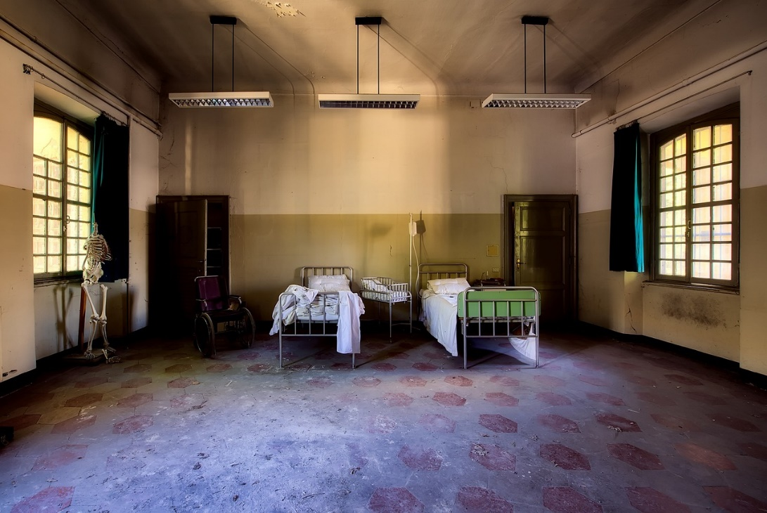

Free for use under the Pixabay [**Content License**](https://pixabay.com/service/license-summary/)

[**12019**](https://pixabay.com/users/12019-12019/)19,690 followers

<https://pixabay.com/photos/temperature-boy-baby-kids-get-sick-5185845/>

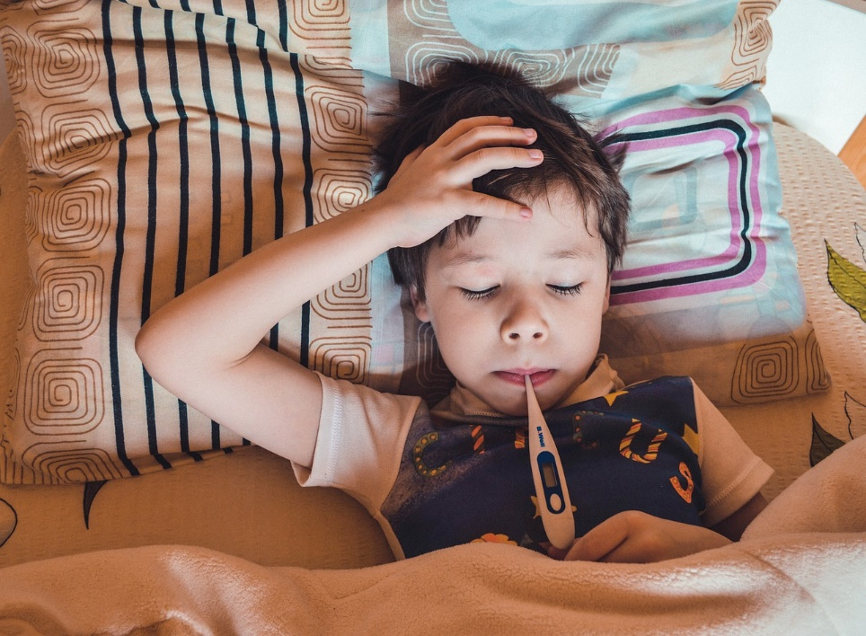

Free for use under the Pixabay [**Content License**](https://pixabay.com/service/license-summary/)

[](https://pixabay.com/users/r-region-6314823/)

[**R-region**](https://pixabay.com/users/r-region-6314823/)12,349 followers

<https://pixabay.com/photos/grandmom-tat-2000c-thermometer-5103358/>

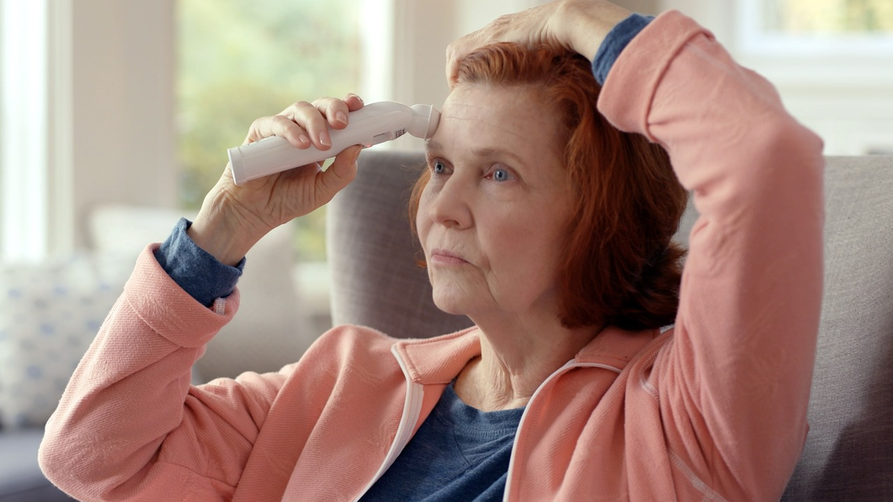

Free for use under the Pixabay [**Content License**](https://pixabay.com/service/license-summary/)

[**ExergenCorporation**](https://pixabay.com/users/exergencorporation-16269701/)5 followers

<https://pixabay.com/photos/elderly-woman-sick-care-man-4169237/>

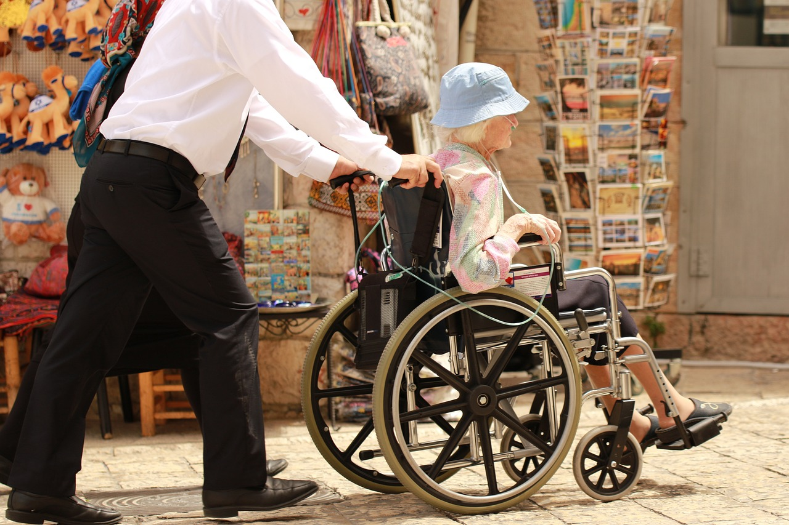

Free for use under the Pixabay [**Content License**](https://pixabay.com/service/license-summary/)

[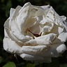](https://pixabay.com/users/ornaw-8155178/)

[**OrnaW**](https://pixabay.com/users/ornaw-8155178/)435 followers